**TECHNICAL REPORT**

**PEMROGRAMAN DESKTOP**

**MODUL 2**



**Disusun Oleh :**

TGL. PRAKTIKUM : Jum’at, 13 November 2020

NAMA : Achmad Farid Alfa Waid

NRP : 190411100073

KELOMPOK : 2

DOSEN : Moh. Kautsar Sophan, S.Kom., M.MT.

TELAH DISETUJUI TANGGAL :

...........................................

ASISTEN PRAKTIKUM

Nadia Asri

(180411100063)

**LABORATORIUM MULTIMEDIA COMPUTING**

**JURUSAN TEKNIK INFORMATIKA**

**FAKULTAS TEKNIK**

**UNIVERSITAS TRUNOJOYO MADURA**

**BAB I**

**TUJUAN DAN DASAR TEORI**

1. **TUJUAN**

Pada praktikum kali ini bertujuan untuk memahami tentang cara pembuatan UI dan Layout dengan menggunakan Qt Designer

1. **DASAR TEORI**

Widget dan Grid Layout menggunakan Qt Designer

**BAB II**

**PEMBAHASAN**

1. **SOAL**
2. Buat aplikasi yang menampilkan tampilan sesuai dengan tugas praktikum di modul 1
3. Jelaskan bagaimana cara agar design kita bisa di jalankan di aplikasi python!
4. **JAWABAN**
5. 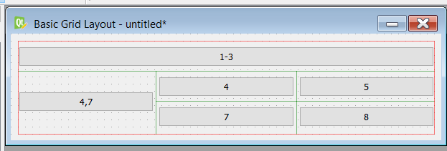

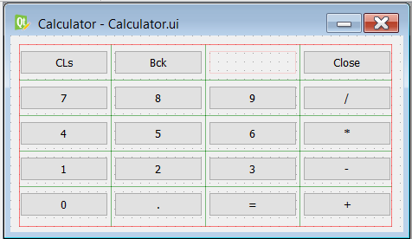

1. 1). File.ui nya harus satu folder dengan pyuic5

2). Jika sudah satu folder, jalankan cmd kemudian masuk ke dalam direktori folder tersebut

3). Kemudian tuliskan script berikut:

* python -m PyQt5.uic.pyuic -x Calculator.ui -o Calculator.py
* python -m PyQt5.uic.pyuic -x Basic_Grid_Layout.ui -o Basic_Grid_Layout.py

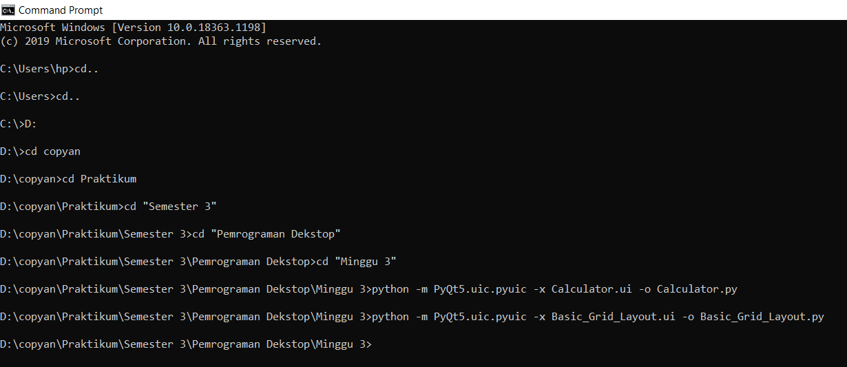

4). Jika sudah selesai, selanjutnya cek ke dalam folder tersebut, jika berhasil terconvert maka bisa dijalankan file pythonnya

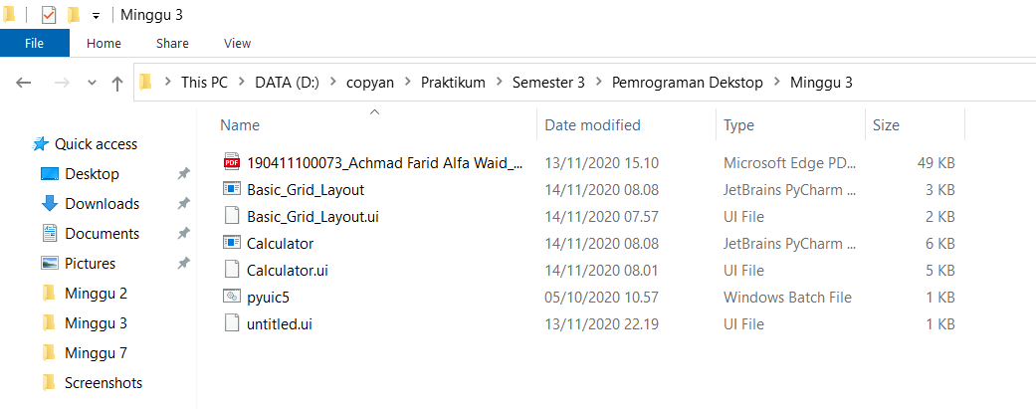

1. **Code Program**
2. Basic_Grid_Layout.py

# -*- coding: utf-8 -*-

# Form implementation generated from reading ui file 'Basic_Grid_Layout.ui'

#

# Created by: PyQt5 UI code generator 5.15.1

#

# WARNING: Any manual changes made to this file will be lost when pyuic5 is

# run again. Do not edit this file unless you know what you are doing.

from PyQt5 import QtCore, QtGui, QtWidgets

class Ui_Form(object):

def setupUi(self, Form):

Form.setObjectName("Form")

Form.resize(600, 149)

self.widget = QtWidgets.QWidget(Form)

self.widget.setGeometry(QtCore.QRect(10, 10, 581, 131))

self.widget.setObjectName("widget")

self.gridLayout_2 = QtWidgets.QGridLayout(self.widget)

self.gridLayout_2.setContentsMargins(0, 0, 0, 0)

self.gridLayout_2.setObjectName("gridLayout_2")

self.pushButton = QtWidgets.QPushButton(self.widget)

self.pushButton.setObjectName("pushButton")

self.gridLayout_2.addWidget(self.pushButton, 0, 0, 1, 3)

self.pushButton_5 = QtWidgets.QPushButton(self.widget)

self.pushButton_5.setObjectName("pushButton_5")

self.gridLayout_2.addWidget(self.pushButton_5, 2, 1, 1, 1)

self.pushButton_3 = QtWidgets.QPushButton(self.widget)

self.pushButton_3.setObjectName("pushButton_3")

self.gridLayout_2.addWidget(self.pushButton_3, 1, 1, 1, 1)

self.pushButton_4 = QtWidgets.QPushButton(self.widget)

self.pushButton_4.setObjectName("pushButton_4")

self.gridLayout_2.addWidget(self.pushButton_4, 1, 2, 1, 1)

self.pushButton_6 = QtWidgets.QPushButton(self.widget)

self.pushButton_6.setObjectName("pushButton_6")

self.gridLayout_2.addWidget(self.pushButton_6, 2, 2, 1, 1)

self.pushButton_2 = QtWidgets.QPushButton(self.widget)

self.pushButton_2.setObjectName("pushButton_2")

self.gridLayout_2.addWidget(self.pushButton_2, 1, 0, 2, 1)

self.retranslateUi(Form)

QtCore.QMetaObject.connectSlotsByName(Form)

def retranslateUi(self, Form):

_translate = QtCore.QCoreApplication.translate

Form.setWindowTitle(_translate("Form", "Basic Grid Layout"))

self.pushButton.setText(_translate("Form", "1-3"))

self.pushButton_5.setText(_translate("Form", "7"))

self.pushButton_3.setText(_translate("Form", "4"))

self.pushButton_4.setText(_translate("Form", "5"))

self.pushButton_6.setText(_translate("Form", "8"))

self.pushButton_2.setText(_translate("Form", "4,7"))

if __name__ == "__main__":

import sys

app = QtWidgets.QApplication(sys.argv)

Form = QtWidgets.QWidget()

ui = Ui_Form()

ui.setupUi(Form)

Form.show()

sys.exit(app.exec_())

1. Calculator.py

# -*- coding: utf-8 -*-

# Form implementation generated from reading ui file 'Calculator.ui'

#

# Created by: PyQt5 UI code generator 5.15.1

#

# WARNING: Any manual changes made to this file will be lost when pyuic5 is

# run again. Do not edit this file unless you know what you are doing.

from PyQt5 import QtCore, QtGui, QtWidgets

class Ui_Form(object):

def setupUi(self, Form):

Form.setObjectName("Form")

Form.resize(454, 227)

self.widget = QtWidgets.QWidget(Form)

self.widget.setGeometry(QtCore.QRect(10, 10, 431, 211))

self.widget.setObjectName("widget")

self.gridLayout = QtWidgets.QGridLayout(self.widget)

self.gridLayout.setContentsMargins(0, 0, 0, 0)

self.gridLayout.setObjectName("gridLayout")

self.pushButton = QtWidgets.QPushButton(self.widget)

self.pushButton.setObjectName("pushButton")

self.gridLayout.addWidget(self.pushButton, 0, 0, 1, 1)

self.pushButton_2 = QtWidgets.QPushButton(self.widget)

self.pushButton_2.setObjectName("pushButton_2")

self.gridLayout.addWidget(self.pushButton_2, 0, 1, 1, 1)

self.pushButton_3 = QtWidgets.QPushButton(self.widget)

self.pushButton_3.setObjectName("pushButton_3")

self.gridLayout.addWidget(self.pushButton_3, 0, 3, 1, 1)

self.pushButton_4 = QtWidgets.QPushButton(self.widget)

self.pushButton_4.setObjectName("pushButton_4")

self.gridLayout.addWidget(self.pushButton_4, 1, 0, 1, 1)

self.pushButton_7 = QtWidgets.QPushButton(self.widget)

self.pushButton_7.setObjectName("pushButton_7")

self.gridLayout.addWidget(self.pushButton_7, 1, 1, 1, 1)

self.pushButton_12 = QtWidgets.QPushButton(self.widget)

self.pushButton_12.setObjectName("pushButton_12")

self.gridLayout.addWidget(self.pushButton_12, 1, 2, 1, 1)

self.pushButton_16 = QtWidgets.QPushButton(self.widget)

self.pushButton_16.setObjectName("pushButton_16")

self.gridLayout.addWidget(self.pushButton_16, 1, 3, 1, 1)

self.pushButton_5 = QtWidgets.QPushButton(self.widget)

self.pushButton_5.setObjectName("pushButton_5")

self.gridLayout.addWidget(self.pushButton_5, 2, 0, 1, 1)

self.pushButton_8 = QtWidgets.QPushButton(self.widget)

self.pushButton_8.setObjectName("pushButton_8")

self.gridLayout.addWidget(self.pushButton_8, 2, 1, 1, 1)

self.pushButton_13 = QtWidgets.QPushButton(self.widget)

self.pushButton_13.setObjectName("pushButton_13")

self.gridLayout.addWidget(self.pushButton_13, 2, 2, 1, 1)

self.pushButton_17 = QtWidgets.QPushButton(self.widget)

self.pushButton_17.setObjectName("pushButton_17")

self.gridLayout.addWidget(self.pushButton_17, 2, 3, 1, 1)

self.pushButton_6 = QtWidgets.QPushButton(self.widget)

self.pushButton_6.setObjectName("pushButton_6")

self.gridLayout.addWidget(self.pushButton_6, 3, 0, 1, 1)

self.pushButton_9 = QtWidgets.QPushButton(self.widget)

self.pushButton_9.setObjectName("pushButton_9")

self.gridLayout.addWidget(self.pushButton_9, 3, 1, 1, 1)

self.pushButton_14 = QtWidgets.QPushButton(self.widget)

self.pushButton_14.setObjectName("pushButton_14")

self.gridLayout.addWidget(self.pushButton_14, 3, 2, 1, 1)

self.pushButton_18 = QtWidgets.QPushButton(self.widget)

self.pushButton_18.setObjectName("pushButton_18")

self.gridLayout.addWidget(self.pushButton_18, 3, 3, 1, 1)

self.pushButton_10 = QtWidgets.QPushButton(self.widget)

self.pushButton_10.setObjectName("pushButton_10")

self.gridLayout.addWidget(self.pushButton_10, 4, 0, 1, 1)

self.pushButton_11 = QtWidgets.QPushButton(self.widget)

self.pushButton_11.setObjectName("pushButton_11")

self.gridLayout.addWidget(self.pushButton_11, 4, 1, 1, 1)

self.pushButton_15 = QtWidgets.QPushButton(self.widget)

self.pushButton_15.setObjectName("pushButton_15")

self.gridLayout.addWidget(self.pushButton_15, 4, 2, 1, 1)

self.pushButton_19 = QtWidgets.QPushButton(self.widget)

self.pushButton_19.setObjectName("pushButton_19")

self.gridLayout.addWidget(self.pushButton_19, 4, 3, 1, 1)

self.retranslateUi(Form)

QtCore.QMetaObject.connectSlotsByName(Form)

def retranslateUi(self, Form):

_translate = QtCore.QCoreApplication.translate

Form.setWindowTitle(_translate("Form", "Calculator"))

self.pushButton.setText(_translate("Form", "CLs"))

self.pushButton_2.setText(_translate("Form", "Bck"))

self.pushButton_3.setText(_translate("Form", "Close"))

self.pushButton_4.setText(_translate("Form", "7"))

self.pushButton_7.setText(_translate("Form", "8"))

self.pushButton_12.setText(_translate("Form", "9"))

self.pushButton_16.setText(_translate("Form", "/"))

self.pushButton_5.setText(_translate("Form", "4"))

self.pushButton_8.setText(_translate("Form", "5"))

self.pushButton_13.setText(_translate("Form", "6"))

self.pushButton_17.setText(_translate("Form", "*"))

self.pushButton_6.setText(_translate("Form", "1"))

self.pushButton_9.setText(_translate("Form", "2"))

self.pushButton_14.setText(_translate("Form", "3"))

self.pushButton_18.setText(_translate("Form", "-"))

self.pushButton_10.setText(_translate("Form", "0"))

self.pushButton_11.setText(_translate("Form", "."))

self.pushButton_15.setText(_translate("Form", "="))

self.pushButton_19.setText(_translate("Form", "+"))

if __name__ == "__main__":

import sys

app = QtWidgets.QApplication(sys.argv)

Form = QtWidgets.QWidget()

ui = Ui_Form()

ui.setupUi(Form)

Form.show()

sys.exit(app.exec_())

1. **Penjelasan Kode Program**

* *class Ui_Form(object):*

*def setupUi(self, Form):*

*Form.setObjectName("Form")*

*Form.resize(600, 149)*

*self.widget = QtWidgets.QWidget(Form)*

*self.widget.setGeometry(QtCore.QRect(10, 10, 581, 131))*

*self.widget.setObjectName("widget")*

Membuat sebuah class dan sebuah fungsi yang berisi beberapa widgets didalamnya

* *self.gridLayout_2 = QtWidgets.QGridLayout(self.widget)*

*self.gridLayout_2.setContentsMargins(0, 0, 0, 0)*

*self.gridLayout_2.setObjectName("gridLayout_2")*

*self.pushButton = QtWidgets.QPushButton(self.widget)*

*self.pushButton.setObjectName("pushButton")*

*self.gridLayout_2.addWidget(self.pushButton, 0, 0, 1, 3)*

Membuat sebuah grid layout untuk dijadikan layout utama

* *self.pushButton_5 = QtWidgets.QPushButton(self.widget)*

*self.pushButton_5.setObjectName("pushButton_5")*

*self.gridLayout_2.addWidget(self.pushButton_5, 2, 1, 1, 1)*

*self.pushButton_3 = QtWidgets.QPushButton(self.widget)*

*self.pushButton_3.setObjectName("pushButton_3")*

*self.gridLayout_2.addWidget(self.pushButton_3, 1, 1, 1, 1)*

*self.pushButton_4 = QtWidgets.QPushButton(self.widget)*

*self.pushButton_4.setObjectName("pushButton_4")*

*self.gridLayout_2.addWidget(self.pushButton_4, 1, 2, 1, 1)*

*self.pushButton_6 = QtWidgets.QPushButton(self.widget)*

*self.pushButton_6.setObjectName("pushButton_6")*

*self.gridLayout_2.addWidget(self.pushButton_6, 2, 2, 1, 1)*

*self.pushButton_2 = QtWidgets.QPushButton(self.widget)*

*self.pushButton_2.setObjectName("pushButton_2")*

*self.gridLayout_2.addWidget(self.pushButton_2, 1, 0, 2, 1)*

*self.retranslateUi(Form)*

*QtCore.QMetaObject.connectSlotsByName(Form)*

Membuat beberapa push button, sekaligus mengatur posisinya.

* *def retranslateUi(self, Form):*

*_translate = QtCore.QCoreApplication.translate*

*Form.setWindowTitle(_translate("Form", "Basic Grid Layout"))*

*self.pushButton.setText(_translate("Form", "1-3"))*

*self.pushButton_5.setText(_translate("Form", "7"))*

*self.pushButton_3.setText(_translate("Form", "4"))*

*self.pushButton_4.setText(_translate("Form", "5"))*

*self.pushButton_6.setText(_translate("Form", "8"))*

*self.pushButton_2.setText(_translate("Form", "4,7"))*

Menamai kembali tampilan yang ada pada masing – masing button sesuai dengan keinginan kita.

* *if __name__ == "__main__":*

*import sys*

*app = QtWidgets.QApplication(sys.argv)*

*Form = QtWidgets.QWidget()*

*ui = Ui_Form()*

*ui.setupUi(Form)*

*Form.show()*

*sys.exit(app.exec_())*

Mendeklarasikan QApplication di dalam variable app, memasukkan value yang ada di class Ui_Form ke dalam variable ui. Kemudian menampilkan variable tersebut dengan fungsi show(), dan membuat system exit.

* *class Ui_Form(object):*

*def setupUi(self, Form):*

*Form.setObjectName("Form")*

*Form.resize(454, 227)*

*self.widget = QtWidgets.QWidget(Form)*

*self.widget.setGeometry(QtCore.QRect(10, 10, 431, 211))*

*self.widget.setObjectName("widget")*

Membuat sebuah class dan sebuah fungsi yang berisi beberapa widgets didalamnya

* *self.gridLayout = QtWidgets.QGridLayout(self.widget)*

*self.gridLayout.setContentsMargins(0, 0, 0, 0)*

*self.gridLayout.setObjectName("gridLayout")*

Membuat sebuah grid layout untuk dijadikan layout utama

* *self.pushButton = QtWidgets.QPushButton(self.widget)*

*self.pushButton.setObjectName("pushButton")*

*self.gridLayout.addWidget(self.pushButton, 0, 0, 1, 1)*

*self.pushButton_2 = QtWidgets.QPushButton(self.widget)*

*self.pushButton_2.setObjectName("pushButton_2")*

*self.gridLayout.addWidget(self.pushButton_2, 0, 1, 1, 1)*

*self.pushButton_3 = QtWidgets.QPushButton(self.widget)*

*self.pushButton_3.setObjectName("pushButton_3")*

*self.gridLayout.addWidget(self.pushButton_3, 0, 3, 1, 1)*

*self.pushButton_4 = QtWidgets.QPushButton(self.widget)*

*self.pushButton_4.setObjectName("pushButton_4")*

*self.gridLayout.addWidget(self.pushButton_4, 1, 0, 1, 1)*

*self.pushButton_7 = QtWidgets.QPushButton(self.widget)*

*self.pushButton_7.setObjectName("pushButton_7")*

*self.gridLayout.addWidget(self.pushButton_7, 1, 1, 1, 1)*

*self.pushButton_12 = QtWidgets.QPushButton(self.widget)*

*self.pushButton_12.setObjectName("pushButton_12")*

*self.gridLayout.addWidget(self.pushButton_12, 1, 2, 1, 1)*

*self.pushButton_16 = QtWidgets.QPushButton(self.widget)*

*self.pushButton_16.setObjectName("pushButton_16")*

*self.gridLayout.addWidget(self.pushButton_16, 1, 3, 1, 1)*

*self.pushButton_5 = QtWidgets.QPushButton(self.widget)*

*self.pushButton_5.setObjectName("pushButton_5")*

*self.gridLayout.addWidget(self.pushButton_5, 2, 0, 1, 1)*

*self.pushButton_8 = QtWidgets.QPushButton(self.widget)*

*self.pushButton_8.setObjectName("pushButton_8")*

*self.gridLayout.addWidget(self.pushButton_8, 2, 1, 1, 1)*

*self.pushButton_13 = QtWidgets.QPushButton(self.widget)*

*self.pushButton_13.setObjectName("pushButton_13")*

*self.gridLayout.addWidget(self.pushButton_13, 2, 2, 1, 1)*

*self.pushButton_17 = QtWidgets.QPushButton(self.widget)*

*self.pushButton_17.setObjectName("pushButton_17")*

*self.gridLayout.addWidget(self.pushButton_17, 2, 3, 1, 1)*

*self.pushButton_6 = QtWidgets.QPushButton(self.widget)*

*self.pushButton_6.setObjectName("pushButton_6")*

*self.gridLayout.addWidget(self.pushButton_6, 3, 0, 1, 1)*

*self.pushButton_9 = QtWidgets.QPushButton(self.widget)*

*self.pushButton_9.setObjectName("pushButton_9")*

*self.gridLayout.addWidget(self.pushButton_9, 3, 1, 1, 1)*

*self.pushButton_14 = QtWidgets.QPushButton(self.widget)*

*self.pushButton_14.setObjectName("pushButton_14")*

*self.gridLayout.addWidget(self.pushButton_14, 3, 2, 1, 1)*

*self.pushButton_18 = QtWidgets.QPushButton(self.widget)*

*self.pushButton_18.setObjectName("pushButton_18")*

*self.gridLayout.addWidget(self.pushButton_18, 3, 3, 1, 1)*

*self.pushButton_10 = QtWidgets.QPushButton(self.widget)*

*self.pushButton_10.setObjectName("pushButton_10")*

*self.gridLayout.addWidget(self.pushButton_10, 4, 0, 1, 1)*

*self.pushButton_11 = QtWidgets.QPushButton(self.widget)*

*self.pushButton_11.setObjectName("pushButton_11")*

*self.gridLayout.addWidget(self.pushButton_11, 4, 1, 1, 1)*

*self.pushButton_15 = QtWidgets.QPushButton(self.widget)*

*self.pushButton_15.setObjectName("pushButton_15")*

*self.gridLayout.addWidget(self.pushButton_15, 4, 2, 1, 1)*

*self.pushButton_19 = QtWidgets.QPushButton(self.widget)*

*self.pushButton_19.setObjectName("pushButton_19")*

*self.gridLayout.addWidget(self.pushButton_19, 4, 3, 1, 1)*

*self.retranslateUi(Form)*

*QtCore.QMetaObject.connectSlotsByName(Form)*

Membuat beberapa push button, sekaligus mengatur posisinya.

* *def retranslateUi(self, Form):*

*_translate = QtCore.QCoreApplication.translate*

*Form.setWindowTitle(_translate("Form", "Calculator"))*

*self.pushButton.setText(_translate("Form", "CLs"))*

*self.pushButton_2.setText(_translate("Form", "Bck"))*

*self.pushButton_3.setText(_translate("Form", "Close"))*

*self.pushButton_4.setText(_translate("Form", "7"))*

*self.pushButton_7.setText(_translate("Form", "8"))*

*self.pushButton_12.setText(_translate("Form", "9"))*

*self.pushButton_16.setText(_translate("Form", "/"))*

*self.pushButton_5.setText(_translate("Form", "4"))*

*self.pushButton_8.setText(_translate("Form", "5"))*

*self.pushButton_13.setText(_translate("Form", "6"))*

*self.pushButton_17.setText(_translate("Form", "*"))*

*self.pushButton_6.setText(_translate("Form", "1"))*

*self.pushButton_9.setText(_translate("Form", "2"))*

*self.pushButton_14.setText(_translate("Form", "3"))*

*self.pushButton_18.setText(_translate("Form", "-"))*

*self.pushButton_10.setText(_translate("Form", "0"))*

*self.pushButton_11.setText(_translate("Form", "."))*

*self.pushButton_15.setText(_translate("Form", "="))*

*self.pushButton_19.setText(_translate("Form", "+"))*

Menamai kembali tampilan yang ada pada masing – masing button sesuai dengan keinginan kita.

* *if __name__ == "__main__":*

*import sys*

*app = QtWidgets.QApplication(sys.argv)*

*Form = QtWidgets.QWidget()*

*ui = Ui_Form()*

*ui.setupUi(Form)*

*Form.show()*

*sys.exit(app.exec_())*

Mendeklarasikan QApplication di dalam variable app, memasukkan value yang ada di class Ui_Form ke dalam variable ui. Kemudian menampilkan variable tersebut dengan fungsi show(), dan membuat system exit.

1. **Hasil Running Program**

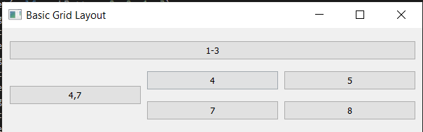

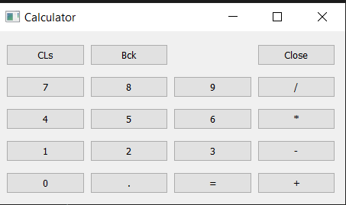

**BAB II**

**PENUTUP**

1. **Kesimpulan**
2. Qt Designer adalah tools untuk mendesain dan membuild Graphical User Interfaces menggunakan QtComponents.
3. Qt Designer tidak hanya dapat digunakan untuk membuat aplikasi desktop, untuk aplikasi mobile juga bisa.
4. kelebihan Qt Designer adalah memungkinkan sebuah team pengembang aplikasi bekerja sama mengembangkan aplikasi dari berbagai platform dengan menggunakan tool-tool dan debugging yang sama
5. **Saran**

Banyak mencoba dan mengekplorasi widget yang lain agar lebih paham